AutoATC

Aviate
Navigate
Communicate

Version 0.9.5 February 2021

Aviation radio telecommunications simulator

Installation and User Guide

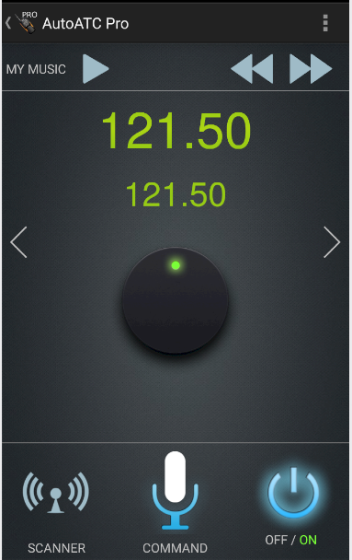

About:
Air Traffic Control communication is a vital component of aircraft safety; particularly during emergency, unusual and partial failure situations.
The biggest loss of life in aviation history (Tenerife 1977) was mostly attributed to miscommunication between aircraft and tower.

AutoATC is the outcome of a need to practice ATC communications in a more "realistic" way. Starting as a proof of concept in December 2017 to assist in helicopter ATC radio communications practice and experience for the PPL(H) license.
AutoATC comes in three components:
AutoATC plugin for Xplane (free X Plane plugin)
- Listen to ATC communications
- Connect the simulator to the Android Applications
https://forums.x-plane.org/index.php?/files/file/45663-main-installation-files-for-autoatc-for-xplane-11/


AutoATC Radio for Xplane (free - Android application)
- Talk to ATC in X Plane

https://play.google.com/store/apps/details?id=org.zem.atctrans

AutoATC Pro (Paid - Android application)
- Talk to ATC in X Plane,
- See the ATC controlled aircraft in X Plane
- Listen to ATC communications
- Practice talking to ATC anywhere.
https://play.google.com/store/apps/details?id=org.zem.atctranspro

Table of Contents
About: 2
Document changes: 3
Installation: 4
Video walk-though: 4
Step 1: 4
Step 2 (first time install only): 4
Install Java: 4
Setup Java 4
WINDOWS: 4
MAC OS: 5
LINUX: 5
Step 3 (post installation setup of AI planes): 5
Airframes JSON 5
Getting Started 7
Control setup 7
Sound Setup 7
Connecting to the android applications 7
Callsign Registration 8
ATC Communications 9
Vocabulary Trainer: 9
Troubleshooting 10
Troubleshooting (windows) 10
Version History 10
0.8.7 b1 (July 2019): 10
0.8.69 (May 2019): 10
0.8.6 rc2 (Febuary 2019): 11
0.8.6 Beta 2 (December 2018): 11
0.8.5.1 (November 2018): 11
0.8.4.2 (October 2018): 11
0.8.4 (October 2018): 11
0.7.3 (October 2018): 11
0.4.3 (September 2018): 11
0.4.2 (September 2018): 12
0.3.7 (August 2018): 12
0.2.0 (July 2018): 12
Airports 13

Document changes:
Version | Changes | Page
0.9.5 | Rewrite document | N/A

Installation:

Step 1:
Extract the files in this archive to:
X Plane 11/Resources/plugins/

Should result in the new folder structure:
X Plane 11/Resources/plugins/AutoATC
and
X Plane 11/Resources/plugins/AutoATC_java

Step 2 (windows only):

Install Microsoft updates:

Two additional executables are included from Microsoft which add support for Multi threading and modern software support which do not ship by default with any windows version.

VC_redist.64.exe

and

vcredist2010_x64.exe

Step 3 (post installation setup of AI planes):
Up to 30 AI planes will be added to the simulator

Each aircraft is controlled by the AI server and has it flight path modelled by the AutoATC pro android application.

The three styles currently supported are:

XSquawkBox style “CSL” models

https://forums.x-plane.org/index.php?/files/file/37041-bluebell-obj8-csl-packages/

These are specified in the file
airframes_bbcsl.json

“Bluebell XL” distributed by Jar Design:
http://jardesign.org/downloads/BBXL/BBXL-1.zip
http://jardesign.org/downloads/BBXL/BBXL-2.zip
http://jardesign.org/downloads/BBXL/BBXL-3.zip

These are specified in the file
airframes_bluebell.json

“World Traffic 3” models
https://forums.x-plane.org/index.php?/files/file/43952-wt3-airlines-and-aircraft-updates/

These require optimisation on first run, the AutoATC log window will display “Still building airframe index” while this is underway, and X-Plane will need restarting after it has completed to use all the airframes.
These are specified in the file
airframes_worldtraffic.json

In order to specify which airframe and livery X-Plane should use, airframe and livery are defined in the directory:

X Plane 11/Resources/plugins/java/airframe_definitions/

Each json file uses the expected default locations for these files, if you have installed them to a different location, you can find and replace in the json file to the directory they are installed.

Airframes JSON
The airframes definitions directory contains several files in json format, which determine the object file which can be used for a particular airframe.

Key | Description
dref | The dataref style to use for animations
path | The path find the actual model
offset | Height to offset the model so that its wheels are on the ground
af | The airframe index, styled as “airframe” “operator”, e.g. A320_ASL is an Air Serbia callsign Airbus A320
type | Currently either “prop” or “jet”, this is used to select the sound file to use.

Version 0.8.6 Beta 2 supports three styles of third party airframes. At each start, plugin will scan the directory installed files, and then create the file

X Plane 11/Resources/plugins/AutoATC_java/airframes_940.txt

This file should not be modified by hand, but can be inspected with wordpad to see which airframes were found.

Getting Started

Control setup
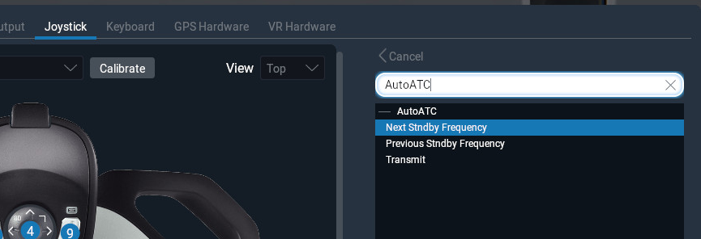

The plugin registers three Xplane commands.
- Next Standby Frequency – move com1 standby frequency forward one.
- Previous Standby Frequency – move com1 standby frequency back one.
- Transmit – Begin voice recognition on a connected android application.

Sound Setup
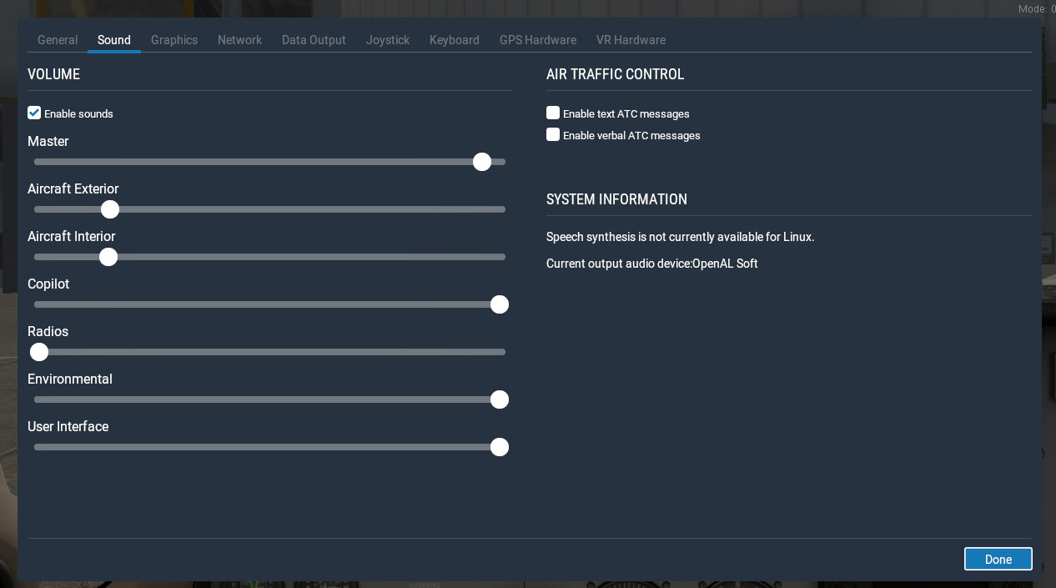
The volume of ATC voice in X-Plane is fixed at maximum volume, in order to stop the voice being drowned out by aircraft noises, turn down the volume of interior and exterior sounds in sound settings.
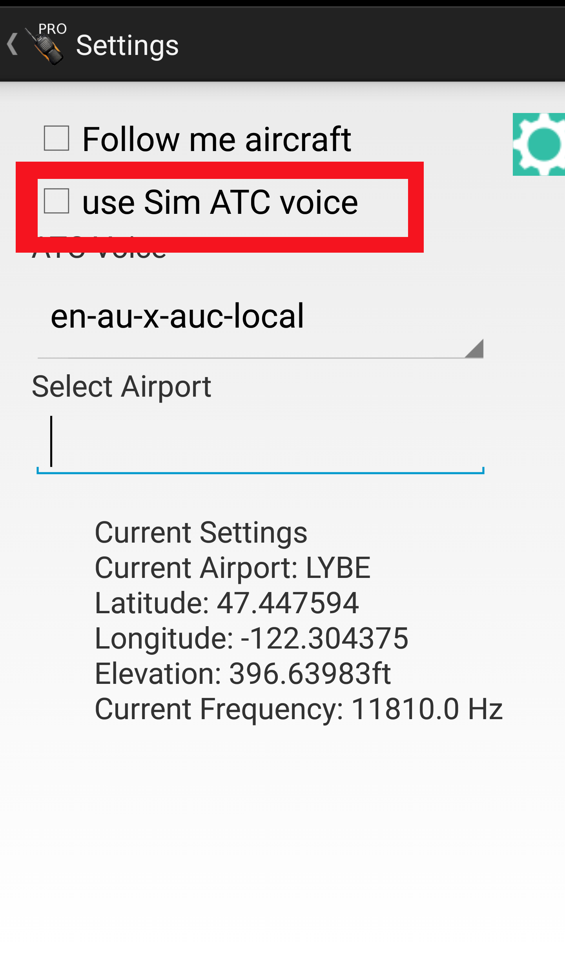

Alternatively, and preferred method, when using AutoATC Pro, disable “Use Sim ATC voice” in the application settings. You can then use a headset with the android device (wired or bluetooth) to both listen and talk to AutoATC.

Connecting to the android applications
Connection to the phone application should be entirely automatic and simply requires the device running the android application and the PC with X-Plane both to be on the same network.

If they are not on the same network, you may specify the device to use by specifying its IP address in

X Plane 11/Resources/plugins/java/mobilesettings.txt

If the Simulator only partially connects to the android device, you should check your PC firewall settings to ensure that the android application can connect to the PC, in windows this can usually be achieved by resetting the firewall to default.

Callsign Registration

In order to communicate with AutoATC, you must first register your callsign.

A video walk-through of registering your callsign is available at:

https://www.youtube.com/watch?v=-3O4Wu1sbwA

To limit the potential disruption caused by bad voice recognition of callsigns, and the burden of an unnecessary username and password system, two “special” ATC calls are used to register your callsign, which are then used when addressing you or replying to any further ATC calls.

These are “good day” and “radio check”.

Interaction with AutoATC is accomplished via the android phone applications, either the free AutoATC Radio when using X-Plane 11 or the paid version which can be used without the simulator.

As with real life radio, you should listen before transmitting to make sure you do not interrupt another transmission.

To maximise recognition accuracy, do not turn your head or vary the distance from the microphone being used with the phone application.

Use a normal conversational tone, but speak loud and clearly at a constant volume while enunciating each word, you must depress the transmit button before speaking and not release it to soon.

The correct rate of speech is about 100 words per minute.

While speaking, avoid hesitation and sounds such as “err” and “umm”, this is both bad radio practice and may cause the voice recognition to miss words.

There are three types of Aircraft callsigns.
- Type A, used by general aviation, where the callsign is the full aircraft registration

- Type B, used by agencies, which is the agency designator plus the last 4 characters of the aircraft registration

- Type C, used for scheduled flights, which is the agency designator plus the flight number.

Callsigns are are often abbreviated, in real life such abbreviations may only be initiated by air traffic control, and how they are abbreviated depends upon the callsign type.

Type A callsigns – aircraft registrations, are shortened to the first character plus at least the last two characters, for example

“Belgrade Tower Golf Bravo Tango Romeo Yankee good day”

….

Alternatively the name of the aircraft manufacturer or model may be used in place of the first character, for example

“Belgrade Tower Piper Golf Bravo Tango Romeo Yankee request radio check”

….

Type B callsigns – are similar to Type A callsigns, except the operating agency designator is used instead of the aircraft manufacturer or model, for example

“Belgrade Tower Speedbird alpha bravo charlie delta radio check”

….

Type C callsigns are not abbreviated, for example

“scandinavian 9 3 7 good day”

….

As part of the language model updates, AutoATC 0.8.6 now has various other autocorrect options, for example, military pilots often shorten “foxtrot” to “fox” (probably their favourite phonetic) AutoATC has the capability to autocorrect these and other common recognition errors as I become aware of them, for example

“Belgrade Tower Yankee Uniform Hotel Fox Kilo request radio check”
...
“Yankee Foxtrot Kilo Belgrade Tower readability 5”

After this, AutoATC will use this callsign even if you omit it or it is recognised incorrectly – this is a small limitation and while not enforced you should follow standard radio procedure when making your calls.

ATC Communications
AutoATC is aimed to replicate standard radio procedure. You should therefore learn the procedures and follow them as if you are flying a real aircraft.

Currently, not all standard procedures are supported by AutoATC. As a general guide, if you hear an AI plane say something, you can say it to, either exactly or with some variation.

The only part of radio procedure which is strictly enforced is that to progress from one flight state to the next, you must correctly make the required read backs.

Additionally, when on the runway and ready to take off, the only command accepted by AutoATC is

“ready for departure”

At no point should you use the words “take off” unless reading back take off instructions.

If you hear the words

“report airborne”

This means you have been given permission to depart and take off at your own discretion. You should call tower with “airborne” once you are in the air.

Vocabulary Trainer:
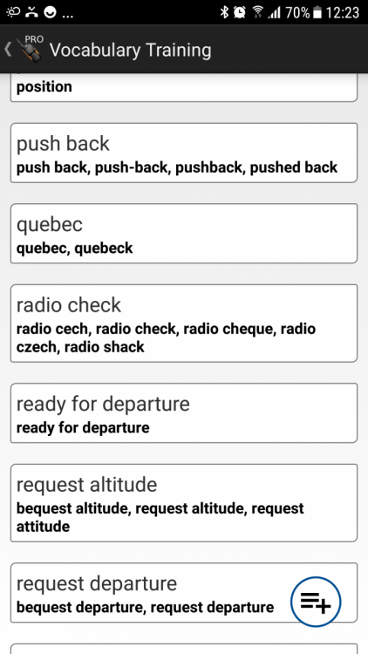
Voice recognition can go wrong for a multitude of reasons. To get around this the android applications include a “vocabulary trainer” (accessible from the top right menu in both the paid and free android applications).
To train the vocabulary, Select an item, press the microphone button, say it then press the button again.
Repeat for any alternates you wish to be recognised (e.g. fife and five)
Swipe an item right to delete/clear.

Troubleshooting
There are two ways the X-Plane plugin can establish a connection to an Android device.
The default is what is called a “broadcast packet”, here the PC shouts on the network "I'm here and want a radio", the android application gets this message and replies with "connect to me here".
Some routers prevent these packets reaching the device.
The alternate when this happens is to specify the address of device.
To do this, get the IP address of the device from its network setting:
The IP address here is “10.10.11.15”

You can now enter this into the settings window in the plugin and press connect:

Troubleshooting (windows)
64bit Java: windows file paths that begin “\Program Files (x86)” indicate 32 bit programs. X Plane and AutoATC are both 64bit bit programs, if java was installed to a file path beginning “\Program Files (x86)” this will not be detected as a jvm that can be used. Please download a 64bit JVM.
Missing msvcr100.dll: The JVM has a dependancy on
﻿C:\windows\system32\msvcr100.﻿dll
Sometimes windows (particularly new machines, or ones without MS office) do not have this installed, it can be downloaded and installed from microsoft from:
﻿﻿https://www.microsoft.com/en-us/download/confirmation.aspx?id=14632

Version History

0.9.5 (February 2021):

0.8.7 b1 (July 2019):
Better android integration (power control, frequency list, flight model etc)
Support for multi PC cockpits with AutoATC Pro android app (set external views as such in Plugins->AutoATC->Settings)
Fix for multiple Java plugins (see https://forums.x-plane.org/index.php?/forums/topic/175706-sharing-the-jvm/)

0.8.69 (May 2019):
RC1
Turn logging back on (ATCLog.txt)
miscellaneous fixes
Compatibility with android application version 0.8.69
B3
“always on” android connection to simulator and api version check.
Ground school
Separated simulator connection and standalone flight modes.
Innumerable bug fixes
LGPL plugin release at https://github.com/mSparks43/XPlane-11-AutoATC-plugin/
Support for custom voice command scripts.
Fixed Mac build.

0.8.6 rc2 (Febuary 2019):
Add vocabulary trainer to android application.
Increase log message visibility to 60 seconds
Add AutoATC/Toggle Log Window command

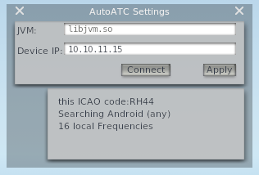
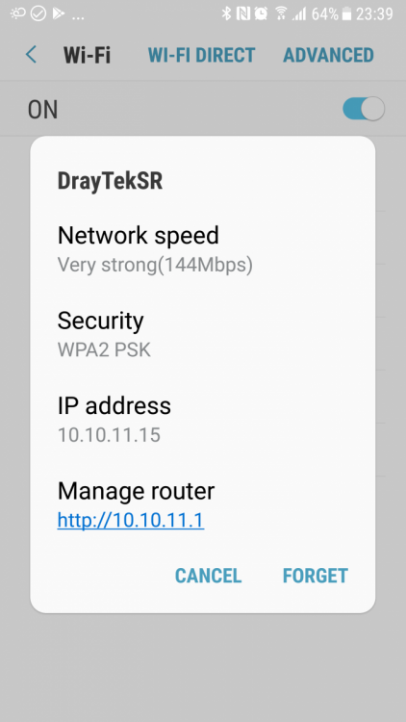
0.8.6 Beta 2 (December 2018):
Airframe definitions for 3rd party AI aircraft models + liveries
Automatically build airframe index from airframe definitions and installed models.
3D Surround Sound engine for AI planes
Added option to AutoATC Pro to always use android application for Text to Speech
- (allows use of a headset plugged into the android device to both hear and talk to ATC)
Added option to AutoATC Pro to select controller voice (with test readout)
Performance optimisations
Added simulator connection notifications to AutoATC for Xplane and AutoATC Pro android applications
Added ATC Logging to simulator plugin (ATCLog.txt)
AI aircraft now obey holding height instructions
AI aircraft now fly entire route when in the presence of a user

0.8.5.1 (November 2018):
Update default jvm to v1.8.192
Available frequency scanner
Next and previous frequency commands
Added "About" and version strings
Add recommended volume settings (seems to be the only way to get the volume right) and control setup screenshot
Track squawk and com1 frequencies on android display
depreciated voice.wav
Fixed occasional clipping/incomplete text to voice
multiple fixes for non functional airports

0.8.4.2 (October 2018):

Stop crash on "restart radio" (new .xpl files now included)
Recover from network software aborts
Add 2 new voices

0.8.4 (October 2018):

Improved voice recognition for longer sentances,
VR Support
Support for android app versions 0.8.4 onward:
New AI Server networking protocol - no more skipped messages.
Busy Skies v2: In simulator AI planes controlled according to ATC instructions (AutoATC Pro only)
voice recognition now displays in the ATC log for a few seconds before sending
- hit transmit before the timer ends to retry
RMS bar in the ATC log "(T)..." and phone apps to ensure voice is being heard by the phone apps
Refactored all the code to allow better testing and proceedure development.

0.7.3 (October 2018):

Merged common codebase for AutoATC Radio and AutoATC Pro

0.4.3 (September 2018):

Fix for some non working windows installations

0.4.2 (September 2018):

Second batch of ATC communication handling fixes.

Support for automatic synchronisation with phone apps (no need to set plane squawk before talking) - new phone applications required ("AutoATC for Xplane" > v1.2.2 or "AutoATC Pro" > v0.4.2), At time of writing may not be fully available from the play store.

Fixed "freeze on startup" (however, it can still take a few seconds to get going, check the AutoATC log from the menu for a change from "Radio powering up" to "ATC Mode:unknown" after powering up an aircraft to see when it is actually active)

0.3.7 (August 2018):

Mac OS support.

Better installation instructions included in the file,

Stability improvements to the plugin for installation setup.

Performance improvements, and better handling of networking failures.

"Busy Skies": All international airports (and a fair few others) now serviced by AI traffic.

First batch of ATC communication handling fixes.

0.2.0 (July 2018):

Added "restart radio" option to the menu.

Bound receiving and transmitting functionality to aircraft battery power (doesn't start until the battery is turned on, and stops when the battery is turned off)

added link to phone app and some more documentation in the description.

